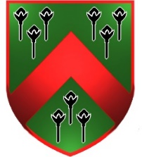

Reminder: Year 2 Trip to Magilligan Beach

Just a reminder about our beach trip on Wednesday.

No uniform.
Dress warmly.
Please remember a Waterproof coat with a hood.
Wear or bring wellies to school (they may not be needed depending on weather).

PACKED LUNCH REQUIRED.

If anyone has any children’s gloves (e.g gardening gloves, etc), please send into school (named) for your child to use at the beach. We have a limited number of gloves. No plastic allowed!

Thank you,
Mrs McCool

If you receive free school meals and require a packed lunch from the canteen, please phone into the office and let them know.

