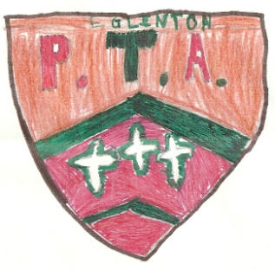
Eglinton Primary School PTA
“Together We Grow”
15th November 2022

NOTICE TO ALL PARENTS/GRANDPARENTS

‘Supper with Santa’ – 6th December 2022

I would like to thank everyone who has offered to help and donated items for the ‘Supper with Santa’ so far. It is only successful through your generosity and kindness so keep up the good work. The following items would be greatly appreciated:

- Cakes, Tray bakes, scones & Mince pies – Homemade or shop bought, everything welcome (return to school by Tuesday 6th December)

- Raffle prizes – we are also running a raffle which helps raise money for School funds if you know of any businesses which can provide a raffle prize.

If you can contact school if you are planning to make/ bring food or prizes for the raffle by phone 02871810252 or email gwilson934@c2kni.net

All donations should be sent into school by Monday 5th December. Again I would like to express our sincerest gratitude in advance for your kindness.

Best regards,

Emma McGuinness
Principal
Eglinton Primary School on behalf of PTA

