|  |  |  |
| --- | --- | --- |
|  | Name | Address |
| 1 |  |  |
| 2 |  |  |
| 3 |  |  |
| 4 |  |  |
| 5 |  |  |
| 6 |  |  |
| 7 |  |  |
| 8 |  |  |
| 9 |  |  |
| 10 |  |  |

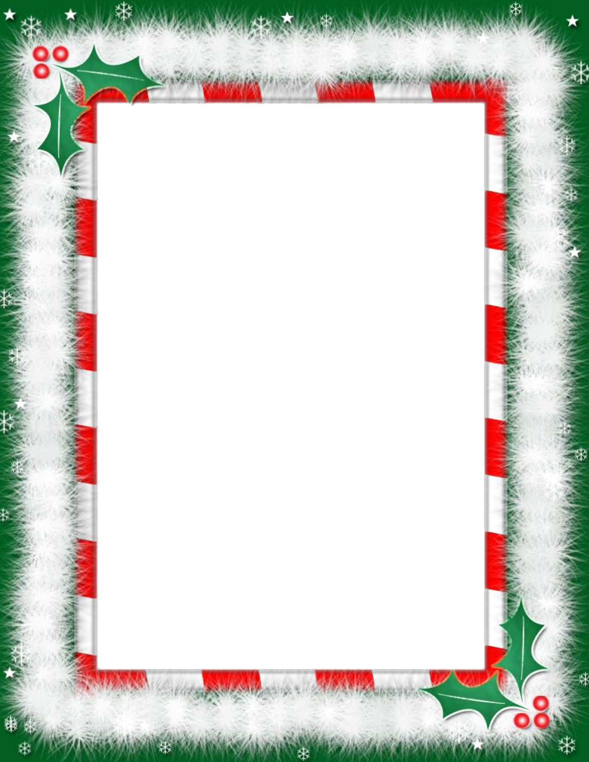

Eglinton Primary School

Christmas Raffle

£1 per line

Return to school before Wednesday 7th December to be included in the raffle.

Draws will take place after Christmas dinner on Wed 7th Dec.